CME 213 Homework 1

Compiling without errors

Question 1.

Q2.

Q: Please complete the code given in main_q2.cpp and demonstrate how this can be done.

Let SparseMatrix and ToeplitzMatrix inherit from Matrix base class



Q3.

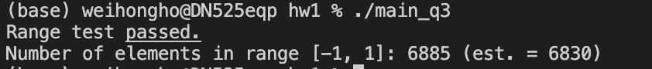

Q4.

1. Use std::transform
2. Use std::all_of
3. Use std::sort , with a special lambda for sorting
4. Use list.sort with special sorting

Submission

